AI WEATHERWISE
Description
The Contact Management System is a robust RESTful backend API built with Node.js and Express.js,utilizing MongoDB Atlas and Mongoose ODM for data persistence. It provides a centralized service for managing personal and professional contact records with full CRUD operations, authentication, and token verification.The platform features secure JWT authentication, bcrypt password hashing, and payload validation to protect API endpoints. It includes custom error handling and request sanitization to ensure API reliability across operational routes.
The platform features secure JWT authentication, bcrypt password hashing, and input validation to protect route endpoints. It includes custom error middleware and request sanitization to ensure API reliability.
Scenario-Based Case Study
BACKGROUND
A user needs a secure and efficient way to store, update, and search contact details across devices without relying on local device storage.
Problem
- Difficulty managing contact lists across multiple clients efficiently.
- Risk of storing unencrypted or unprotected user information.
- Lack of standardized search and validation mechanisms for phone numbers and email records.
- Solution
- The Contact Management System provides a centralized API that handles user authentication and contact lifecycle operations. It enforces secure data mapping via Mongoose schemas to protect user identity and contact records.

Solution
The Contact Management System provides a centralized API that handles user authentication and contact lifecycle operations. It enforces secure data mapping via Mongoose schemas to protect user identity and contact records.
Usage
- User Usage: Registers, logs in, creates contacts, edits contact details, searches stored contacts, and deletes obsolete entries.
- Developer/Admin Usage: Monitors API health, manages database connections, and verifies protected endpoint access via token authentication.

Outcome
By implementing structured JWT middleware and centralized data persistence, contact data remains consistent, validated, and accessible only to authenticated accounts.

1. Software Requirements
Operating System: Windows 10/11, macOS, or Linux
Node.js (v16 or above): Runtime ecosystem running server logic and routing infrastructure.
npm (v8 or above): Package manager to control operational dependencies.
MongoDB: Document NoSQL database for storing user accounts and contact schemas.
Mongoose: ODM framework for schema validation and database modeling.
Postman / Thunder Client: API verification toolkits to test endpoints and validate JSON responses.
Code Editor: Visual Studio Code.
2. Hardware Requirements
Processor: Intel Core i3 (8th Gen or above) / AMD Ryzen 3 or equivalent.
RAM: 4 GB minimum (8 GB recommended for concurrent backend testing).
Storage: 500 MB of available disk workspace.
Key Features
JWT Authentication: Secure token generation and verification for user login sessions.
Protected Routes: Middleware guards /api/contacts routes to restrict access strictly to token owners.
CRUD Operations: Complete endpoint functionality for creating, fetching, updating, and deleting contact records.
Input Sanitization & Validation: Ensures required fields (name, email, phone) are provided before writing to the database.
Roles and Responsibilities
Admin / System Manager:
Monitors API endpoints and database uptime.
Configures environment variables and security tokens.
Registered User:
Creates an account and logs in to obtain an authentication token.
Adds new contacts with name, email, and phone information.
Views, updates, or deletes personal contact entries.

User Flow
User registers a new account (POST /api/users/register).
User logs in to receive a JWT access token (POST /api/users/login).
User attaches the token to the Authorization header for subsequent requests.
User fetches all created contacts (GET /api/contacts).
User creates, edits, or deletes a contact via dedicated HTTP methods (POST, PUT, DELETE).
Epic 1: PROJECT ARCHITECTURE
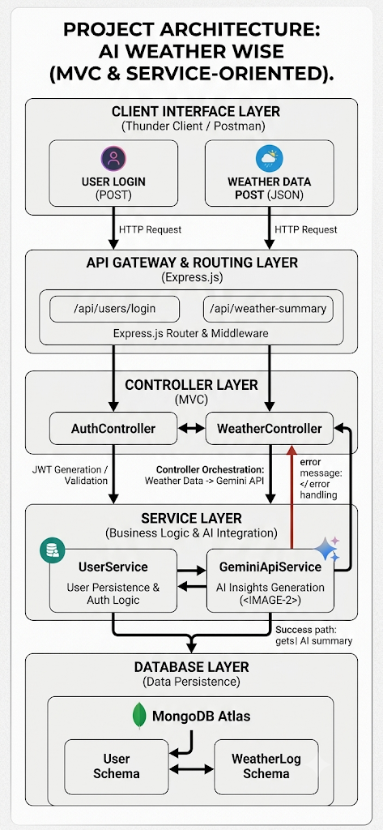
The application follows the MVC (Model-View-Controller) pattern to decouple business logic, request routing, and database persistence.

Components Definition
Interface: Tools like Thunder Client or Postman send requests to predefined API route paths.Express Server Gateway: Listens on configured ports, parses JSON request
bodies, handles CORS, and routes traffic.Authentication Middleware: Validates JWT headers to guard protected endpoints (/api/contacts).
Controllers: Handles request logic, interacts with Mongoose models, and formats JSON responses.
Database Layer: Mongoose executes CRUD operations against MongoDB collections.

Entity-Relationship (ER) Structure
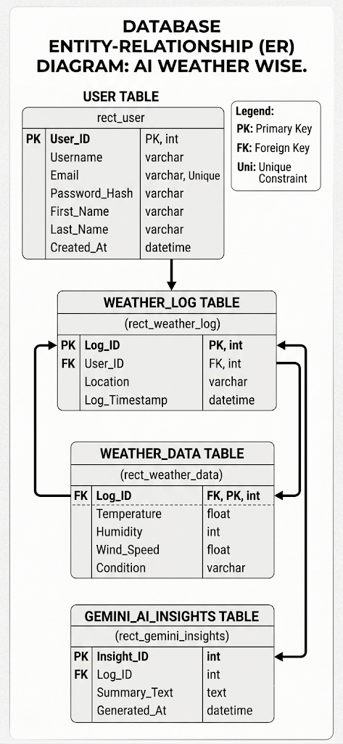
1. User Entity
_id (Primary Key - ObjectId)
username (String, Required)
email (String, Required, Unique)
password (String, Hashed, Required)
createdAt (Date, Default: Now)
2. Contact Entity
_id (Primary Key - ObjectId)
user_id (Foreign Key referencing User Collection)
name (String, Required)
email (String, Required)
phone (String, Required)
createdAt (Date, Default: Now)
Key Structural Mappings
User to Contact (One-to-Many): A registered user can create and manage multiple contact records.
AI WEATHERWISE APL USER WORKFLOW EXPLANATION
Authentication (Login / Signup):
The client/user sends authentication credentials (email, password) to the /api/users/login endpoint.
The server validates the credentials and responds with a JWT authorization token.
Submitting Weather Metrics:
The client sends a POST request to /api/weather-summary with the required request body parameters (city, temperature, humidity, windspeed, condition).
The request includes the Authorization header containing the user's JWT token.
Validation & Middleware Processing:
Express middleware validates the authorization token and checks if the incoming payload is valid JSON.
If invalid: Returns an appropriate error status code (e.g., 400 Bad Request or 401 Unauthorized)
AI Summary Generation via Gemini API:
The WeatherController receives the verified weather metrics and delegates processing to the GeminiApiService.
The service calls Google Gemini AI to analyze environmental metrics (temperature, humidity, condition) and craft a natural language weather overview
JSON Response Dispatch:
The server returns a 200 OK status response containing the AI-generated weather insights back to the client:
JSON
{
"success": true,
"summary": "Today's weather in Chennai is warm and rain with moderate humidity."
}

MVC Architecture Pattern
The AI WeatherWise application follows the Model-View-Controller (MVC) design pattern combined with a service-oriented approach to decouple business logic, client requests, and database persistence.
+------------------------------------+
| Client Interface Layer |
| (Thunder Client / Postman) |
+--------------------+---------------+
|
HTTP Requests
|
v
+------------------+---------------------+
| API Gateway & Routing Layer |
| (Express.js) |
+------------------+----------------------+
I
v
+----------------+----------------------+
| Controller Layer |
| (AuthController / WeatherCtr) l
/ \
/ \
v v
+----------------------+ +-------------------------------+
| Service Layer | | Model Layer |
| (Gemini API | | (Mongoose Schemas l
+---------------------+ l MongoDB) l
+-------------------------------+

Architecture Layers Overview
1. Model Layer (Data Blueprints)
Role: Defines the structural schemas and data validation rules for
storing entities inside MongoDB Atlas.
Implementation:
User Schema: Stores account details including Username, Email, and hashed passwords.
Weather Schema: Defines structured schemas for environmental logging and caching historical metrics (Temperature, Humidity, Wind_Speed, Condition).
2. View Layer (Routing & Network Interface)
Role: In this headless RESTful API backend context, traditional UI view templates do not exist. Instead, the View Layer acts as an API Routing & Network Interface.
Implementation:
Exposes HTTP endpoints (/api/users/login, /api/weather-summary) to receive JSON request bodies and return structured JSON responses back to the client.
3. Controller Layer (Execution Matrix)
Role: Acts as the central orchestrator of the system. It captures incoming request vectors from client routes, executes request validation, and delegates processing workflows.
Implementation:
AuthController: Manages user registration, credential verification, and JWT access token generation.
WeatherController: Receives weather data payloads, performs parameter validation, forwards data to the AI service, and formats JSON output.
4. Service Layer (Business Logic & AI Orchestration)
Role: Encapsulates core application logic and external API integrations away from controllers.
Implementation:
GeminiApiService: Interfaces with Google Gemini AI to analyze environmental parameters (city, temperature, humidity, windspeed, condition) and generate natural language weather summaries.
UserService: Handles security logic, password hashing via bcrypt, and database mapping.

EPIC 2: Project Setup and Configuration
This section provides a step-by-step guide to installing, configuring, and running the AI WeatherWise backend API locally on your system.
1. Prerequisites
Before setting up the project, ensure you have the following installed on your machine:
Node.js: v16.0.0 or higher
npm: v8.0.0 or higher
Git: Version control system
MongoDB Atlas Account: Active cluster for hosting cloud database collections
Google Gemini AI API Key: API key from Google AI Studio
API Client: Thunder Client extension for Visual Studio Code or Postman
2. Directory & File Structure
Organize your backend workspace according to the Model-View-Controller (MVC) pattern:
ai-weatherwise-backend/
├── config/
│ └── db.js # MongoDB Atlas connection setup
├── controllers/
│ ├── authController.js # User registration and login handlers
│ └── weatherController.js # Weather summary logic and Gemini integration
├── middleware/
│ ├── authMiddleware.js # JWT token validation middleware
│ └── errorHandler.js # Centralized JSON error handling
├── models/
│ ├── User.js # Mongoose schema for User collection
│ └── WeatherLog.js # Mongoose schema for Weatherecord
├── routes/
│ ├── authRoutes.js # Endpoints for /api/users
│ └── weatherRoutes.js # Endpoints for /api/weather-summary
├── services/
│ └── geminiService.js # External Google Gemini AI API integration
├── .env # Environment variables configuration
├── .gitignore # Ignored files (node_modules, .env)
├── package.json # Project dependencies and scripts
└── server.js # Express server gateway entry point

3.Installation Steps
Step 1: Clone or Create Project Directory
Open your terminal and create a dedicated project folder:
mkdir ai-weatherwise-backend
cd ai-weatherwise-backend
Step2: Initialize Node.js ApplicationInitialize a new Node.js project to generate the package.json file: npm init –y step3: Install Required Dependencies
Install Express, Mongoose, JWT, bcrypt, Dotenv, and Google Generative AI SDK:
npm install express mongoose dotenv jsonwebtoken bcryptjs @google/generative-ai cors
Install nodemon as a development dependency for automatic server reloads:npm install-D nodemon
4. Environment Variables Configuration (.env)
Create a .env file in the root directory of your project and configure the required environment variables:
# Server Configuration
PORT=5000

# MongoDB Atlas Database Connection
MONGO_URI=mongodb+srv://<username>:<password>@cluster0.ad723.mongodb.net/ai_weatherwise?retryWrites=true&w0=majority

# JWT Authentication Secret Key
JWT_SECRET=your_super_secret_jwt_key_here

# Google Gemini AI Service API Key
GEMINI_API_KEY=your_google_gemini_api_key_here

5.Running the Application
Configure Startup Scripts
In your package.json file, add the start script:
"scripts": {
"start": "node server.js",
"dev": "nodemon server.js"
}
Expected Terminal Output
Upon a successful connection, your terminal will display:

[nodemon] 3.1.0
[nodemon] to restart at any time, enter `rs`
[nodemon] watching path(s): *
[nodemon] watching extensions: js,mjs,json
[nodemon] starting `node server.js`
MongoDB Connected: cluster0.ad723.mongodb.net
Server running on port 5000
6. Verifying API Endpoints
Using Thunder Client or Postman, test the server setup:
User Login (POST):
http://localhost:5000/api/users/login
Weather AI Summary (POST):
http://localhost:5000/api/weather-summary

EPIC 3: BACKEND DEVELOPMENT
Project file structure
ai-weatherwise-backend/
├── config/
│ └── db.js
├── controllers/
│ ├── aiController.js
│ ├── authController.js
│ ├── locationController.js
│ └── weatherController.js
├── middleware/
│ └── authMiddleware.js
├── models/
│ ├── Location.js
│ └── User.js
├── routes/
│ ├── aiRoutes.js
│ ├── authRoutes.js
│ ├── locationRoutes.js
│ └── weatherRoutes.js
├── services/
├── app.js
├── server.js
├── .env
├── .gitignore
├── package-lock.json
├── package.json
├── postman_collection.json
└── README.md
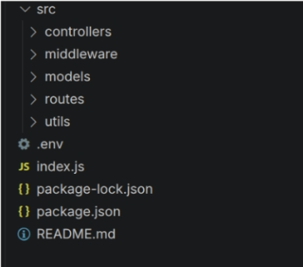

Application Entry Point (server.js)
The server.js file serves as the main entry point of the application. It initializes the Express server, loads environment variables, configures middleware, establishes the MongoDB connection, registers API routes, and starts the server after a successful
database connection.
EPIC4: database configuration
The database configuration module utilizes mongoos ODM to establish an asynchronous connection with the cloud_hosted MONGODB Atlas database cluster.
Database connection implementation
Location schema:

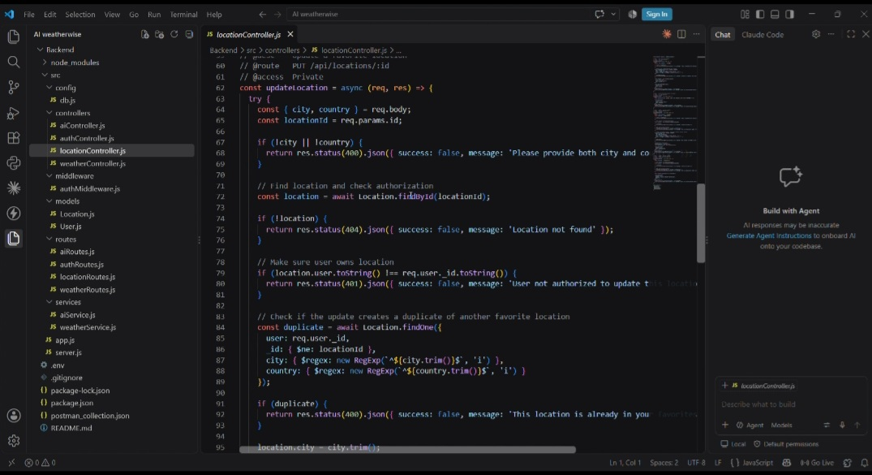
EPIC 5: PROJECT EXECUTIONS:
1. Server Setup & Database Connection
Objective: Verify that the Express server initializes correctly and establishes a connection with the MongoDB Atlas cloud database.
Express server started and listening on Port 5000.
Connection string initialized, returning successful database status:
2. User Authentication (Login Endpoint)
Objective: Test user authentication and JWT token generation upon valid login credentials.
3. AI Weather Summary API Endpoint
Objective: Generate real-time, AI-driven weather summaries by processing weather attributes using the Google Gemini API integration.
Execution Details:
Request Body (JSON): Sends location parameters (e.g., City: Chennai, temperature, humidity).
Response: Returns 200 OK status with "success": true and the dynamic weather summary string generated.
Screenshot Placeholder: Insert screenshot of Thunder Client interface showing the POST /api/weather-summary request and response payload.
4. Mongoose Data Models & Schemas
Objective: Define structured data schemas for database operations using Mongoose ORM.
Files: models/User.js and models/Location.js
Execution Details:
User Schema: Enforces username, unique email constraint, and password validation.

Location Schema: Stores saved user locations with fields for city, country, user reference ID, and a compound index to prevent duplicate user-location entries

Running the Backend Server
The AI WeatherWise backend server runs locally using Node.js and connects to MongoDB for database operations. Follow the steps below to execute the server:
Step 1: Install Dependencies
Before starting the server for the first time, install all necessary project dependencies using npm:
npm install
Step 2: Environment Setup
Ensure that the .env file is properly configured with the required environment variables, including MONGO_URI, PORT, JWT_SECRET, and GEMINI_API_KEY.
Step 3: Start the Development Server
Launch the Node.js backend server using the configured start script:
Step 4: Server Startup & Database Connection
Upon successful execution, the backend server initializes on the designated port and establishes a connection to MongoDB.
API Testing:
Register API:
Login API:

Weather API:

Recommendation API:

API Testing Video Link:
https://drive.google.com/file/d/1Ffq_vzW7SRfgjPWefovU9Y73LTlCh4jk/view?usp=drivesdk
DEMO Video Link:
https://drive.google.com/file/d/1xJr-Dz_Fnk5XLF_8grygtkG97_wqIynx/view?usp=drivesdk

